Introduction to Cells

A cell is the smallest unit that is alive. This means that a cell is the smallest unit that has the characteristics of life. For example, cells can respond to their environment, acquire and use energy, grow, reproduce, and maintain homeostasis.

1. Watch the video of an animal cell chasing and then eating bacteria (https://www.youtube.com/watch?v=Z_mXDvZQ6dU). What are two characteristics of life that are demonstrated by this animal cell?

To carry out the activities of life, all cells have the following parts:
- DNA, the genetic material, which gives the instructions for making proteins
- ribosomes, the molecular machines that make proteins
- a cell membrane that surrounds the cell and regulates what gets into and out of the cell
- cytoplasm, which includes:
  - the cytosol (water with dissolved proteins and other substances)
  - the structures in the cytosol, including ribosomes and a cytoskeleton, which is a network of protein fibers that contribute to structure and movement of the cell.
(For example, molecular changes in the proteins of the cytoskeleton caused the movement of the animal cell as it chased the bacterium.)

2. Describe how the cell parts listed in this table contribute to the activities of life.

Cell Parts | How These Cell Parts Contribute to the Activities of Life
DNA and ribosomes
Cell membrane

3. You may have noticed that the animal cells in the video were much bigger than the bacteria. In this activity, you will learn about other differences between these two types of cell. Based on what you already know, draw diagrams of an animal cell and a bacterial cell, and label as many parts as you can.

Animal Cell | Bacterial Cell

Animal cells and bacterial cells are examples of two fundamentally different types of cells, which are described in this table and the figure below.

In a eukaryotic cell, the DNA is surrounded by a nuclear membrane. | In a prokaryotic cell, the DNA is not surrounded by a membrane.
An animal, plant or fungus has multiple eukaryotic cells. There also are some single-cell eukaryotic organisms. | A prokaryote is an organism that consists of a single prokaryotic cell. Bacteria are prokaryotes.

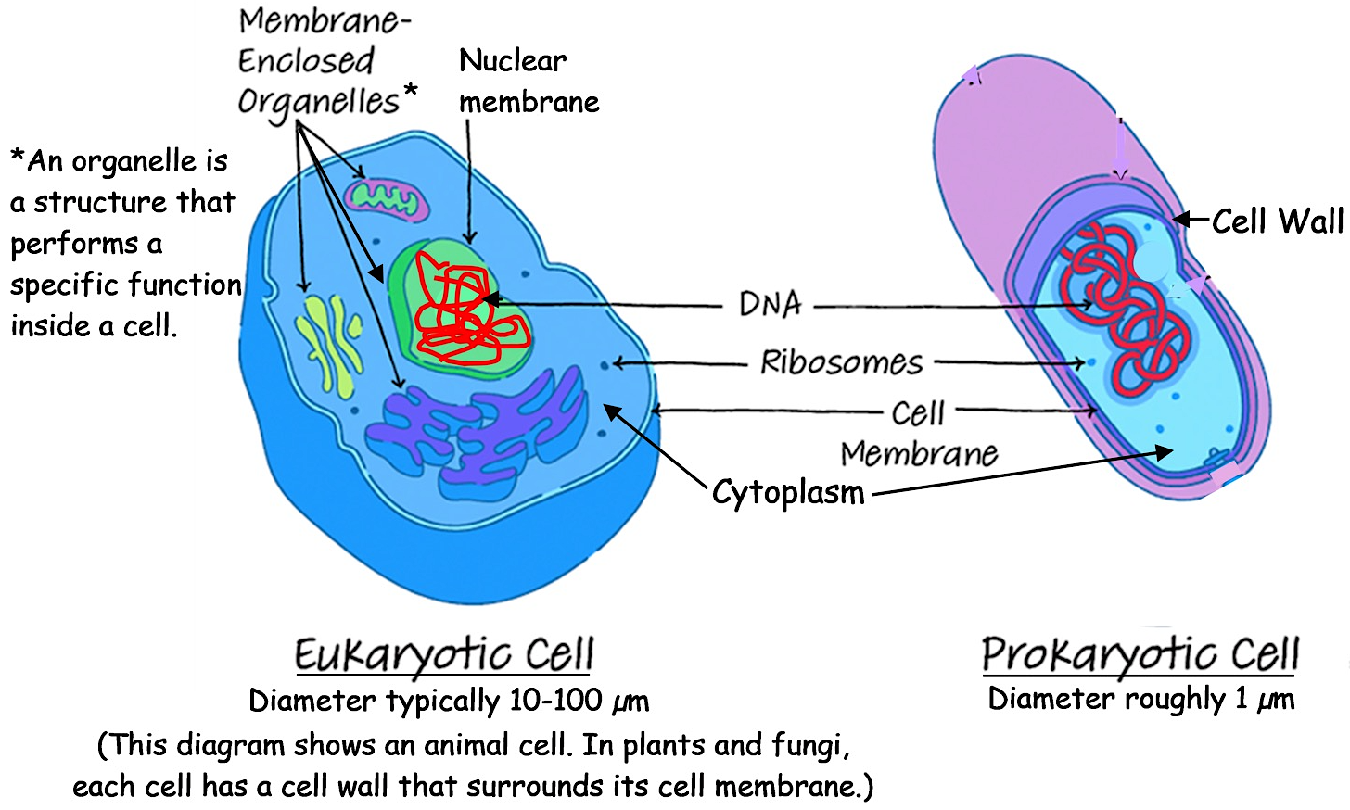

4a. Based on the information in the figure, the diameter of an animal cell is ____ - ______ times bigger than the diameter of a bacterium.

4b. Draw the outline of a prokaryotic cell which is about 1/10 as long as the diagram of the eukaryotic cell. This will give a more realistic picture of how much smaller a prokaryotic cell is.

Some prokaryotes have chemical abilities that eukaryotic cells lack. All organisms need nitrogen atoms in the amino acids in their proteins. Some types of prokaryotes can use the abundant nitrogen molecules (N₂) in the air to make ammonium ions (NH₄⁺). Plants and animals also need nitrogen atoms in their amino acids, but they cannot use N₂ from the air. Fortunately, excess NH₄⁺ produced by prokaryotes is available for plants to use to make amino acids. Animals get nitrogen atoms by consuming proteins in the food they eat.

5. Some types of prokaryotes can cause diseases such as tuberculosis or Lyme disease. However, we would not be better off if we could somehow eliminate all prokaryotes. Describe one way that humans need prokaryotes.

Your body has about 30 trillion tiny human cells and roughly the same number of even tinier prokaryotic cells. Because prokaryotic cells are so much smaller than animal cells, the total weight of the prokaryotes living in and on your body is only about 0.2 kg (less than half a pound). The prokaryotes that live in your gut and on your skin benefit you by making some vitamins and improving your digestion and resistance to infection. In turn, these prokaryotes benefit from the food and shelter provided by your body.

How does your body manage to pack in trillions of cells? The answer is that your body is much much bigger than your cells. (Notice the logarithmic scale in the figure below.)

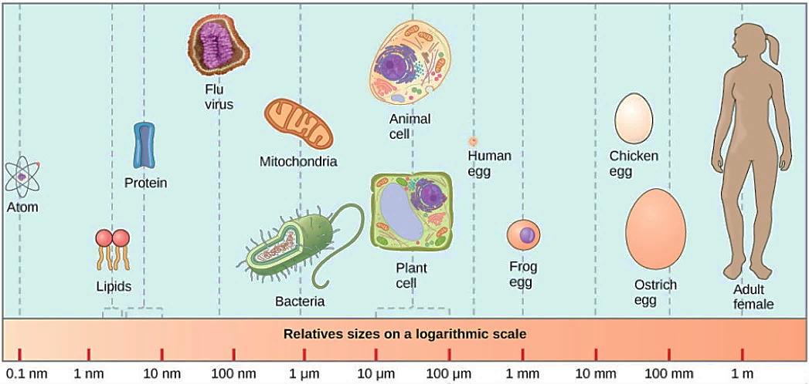

6. Even though there are roughly the same number of human cells and prokaryotic cells in your body, almost all of the weight of your body is due to the human cells. Explain why.

7. View the animation at https://learn.genetics.utah.edu/content/cells/scale/. Which is the biggest? a grain of salt ___ a red blood cell ___ a skin cell ___

To review and learn more, watch the video, “Prokaryotic vs. Eukaryotic Cells” (https://www.youtube.com/watch?v=Pxujitlv8wc).

Medicines to cure infections work by interfering with molecular processes in the infecting organism. The video mentions that, because of molecular differences between bacteria and fungal cells, different kinds of medicines are needed to treat bacterial and fungal infections. There also are fundamental molecular differences between bacteria and archaea, two types of prokaryotes that have evolved separately for more than 2 billion years.

8. Many medicines that inhibit the growth of bacteria do not work against archaea. Propose a likely explanation.

An organelle is a structure that performs a specialized function inside a cell. All cells have ribosomes, which make proteins. In addition, eukaryotic cells have several types of organelles that are surrounded by membranes.
- The nucleus contains the DNA which gives the instructions for making proteins.
- The rough endoplasmic reticulum is a network of membranes that processes proteins that will be secreted from the cell (e.g., a protein hormone). Vesicles carry these proteins to the Golgi apparatus where these proteins are processed some more. Then, other vesicles carry these proteins to the cell membrane where they are secreted from the cell.
- Mitochondria make ATP, which provides the energy needed for many cellular processes. Mitochondria need oxygen and glucose as inputs.
- In animal cells, lysosomes digest worn out cellular materials. In cells that eat disease-causing bacteria, lysosomes have enzymes that digest any bacteria that the cell has eaten.

9a. This diagram of an animal cell shows several cell parts that work together to make and secrete proteins that are released from the cell. Next to the name of each of these cell parts, briefly describe its function.
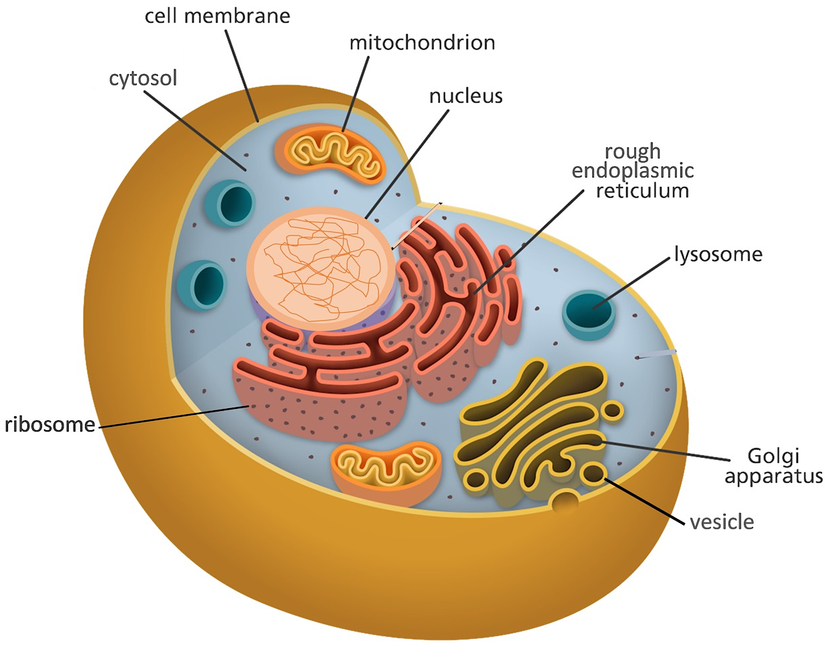

9b. Circle the name of the organelle that makes the ATP that provides the energy for protein synthesis and secretion.

This diagram shows the organelles as static and separate. In contrast, inside a living cell there is constant activity and the organelles cooperate to accomplish the activities of life. To see an animation that illustrates some of this activity, watch from 3 minutes and 14 seconds to 6 minutes and 30 seconds in the video, “The Inner Life of the Cell” (https://vimeo.com/152402052); don’t worry if you don’t understand everything the narrator says.
Plant cells have several cell parts that are not found in animal cells, including:
- chloroplasts, which carry out photosynthesis to make the sugar, glucose;
- the cell wall, which provides structural support;
- the large central vacuole, which stores cell nutrients and waste products.
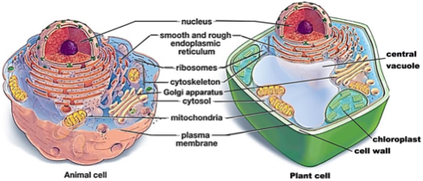

10. In the diagram of the plant cell draw an arrow from the organelle that makes glucose to the organelle that uses glucose in a process that makes ATP.

11. Explain why each of the structures listed in the table is useful for plant cells, but not needed or even a disadvantage for animal cells.

 | Why This Part  is Useful in Plant Cells | Why This Part is Not Needed or is  Even a Disadvantage for Animal Cells
Chloroplasts
Cell wall

12. Complete this Venn diagram to summarize what you have learned about eukaryotic and prokaryotic cells. List characteristics that are observed only in eukaryotic cells, only in prokaryotic cells, or in both eukaryotic and prokaryotic cells. Also, list the kinds of organisms that have eukaryotic cells or are prokaryotic cells.
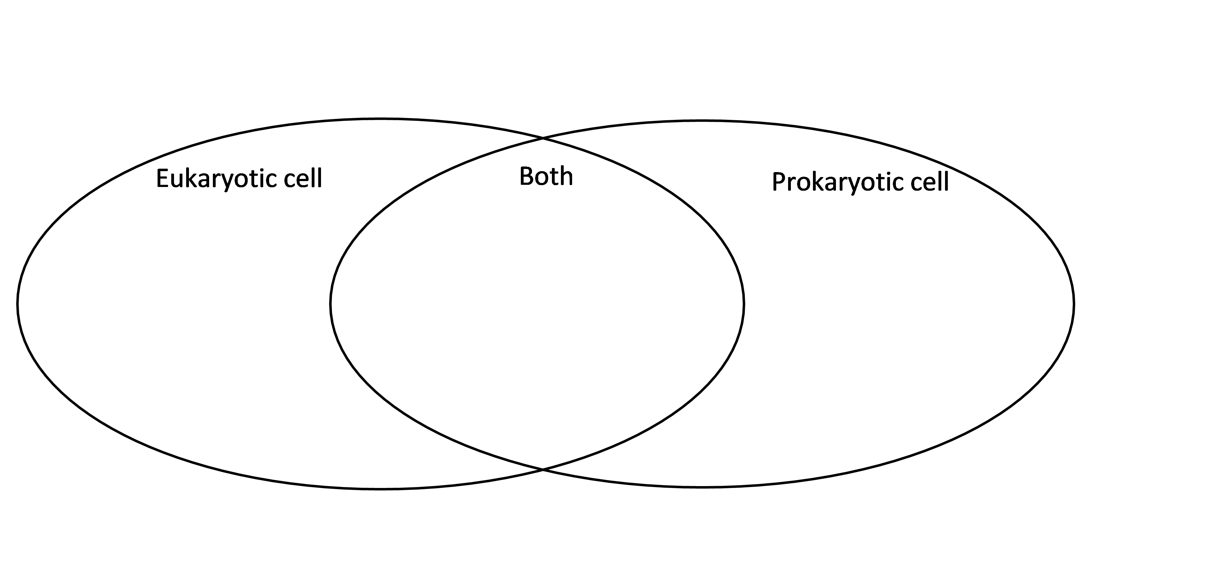

By Dr. Ingrid Waldron, Department of Biology, University of Pennsylvania, © 2024. This Student Handout and Teacher Notes with instructional suggestions and background biology are available at https://serendipstudio.org/exchange/bioactivities/CellIntro.

